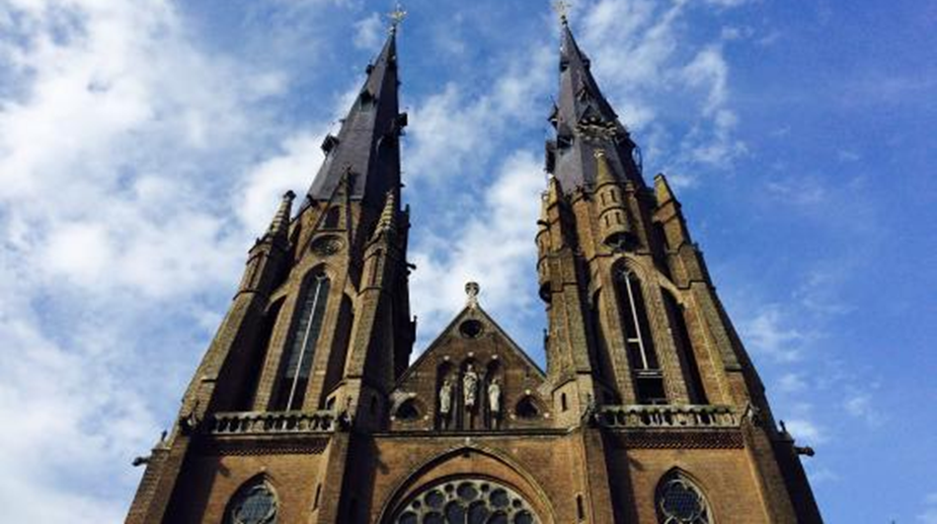

PUBLIC PEACE MEAL, Friday September 29, 2017
On the steps of Catharina church Eindhoven from 12.00-14.00

We have been seeking peace for centuries. Winning a war or expelling ISIS from Raqqa or Mosul, demands many sacrifices and still does not bring peace. At the moment, the conflicts in the world seem to be expanding. Also in Eindhoven we have big and small contrasts. At the Peace Meal, everyone can enjoy, meet and engage in a conversation about justice, peace, security and ‘feeling at home’. Whoever wants to, is invited to perform with music, poetry or ... . At 12 o'clock three groups of four participants start dialogues about 'feeling at home'. Under the guidance of an experienced conversation leader you will be able to get acquainted and discover what feeling at home may mean. Also for those who come later there is a good company, enough to talk and eat as long as the stock extends. The meal is prepared by professional cooks from the Middle East and the proceeds are for Hîvî school in Kobanê / Ayn al-Arab in Northern Syria. Hîvî means Hope and is a pre-school for disabled children in a war-wrecked city. We hope that after this meeting everyone will continue happy with new energy and maybe new plans.

Location: Steps of Catharina Church, Kerkstraat 1, Eindhoven.
Date and time: Friday 29 September, 2017, 12.00 – 14.00 hrs
Dialogue: during the meal there will be 3 dialogue tables on the theme “feeling at home”
For maximum 12 people, who are present at 12.00.
Exhibition: you are also invited to visit the exhibition 'Aleppo 1 to 12' : images from Aleppo' in the town hall, till 16.00.
Cost: Contribution to personal capacity,
Benefits: for education of handicapped children in Kobanê / Ayn-'Al Arab in Northern Syria

Organization: Stichting Vredesburo Eindhoven [Peace Bureau, Eindhoven] Tel. 040-2444707
and working party: Eindhoven- Kobanê, email info@eindhovenkobane.nl
in cooperation with : ‘Eindhoven in Dialogue’

